* Arduino take 6-20 V
* It is recommended to use 9V (Vin pin and Power Port)
  + Both Vin and Power Port go thru a linear regulator but only Power Port have a Reverse Voltage Protection Diode (which drop 0.7V)
  + The regulator set Vout at 5V (require at least 1V drop)
  + The Voltage difference get absorb through the load P=(9-5)\*I^2
  + Higher the battery voltage put more power on the load which create higher heat (Arduino regulators don’t have heat sink)
* Current:
  + Arduino: 20mA to 50mA
  + Load Cell and HX711: 1.5mA (2.7V to 5V)
  + PIR: 65mA (5V to 20V) (50uA standby mode)
  + IR: 33mA (4.5V to 5.5V)

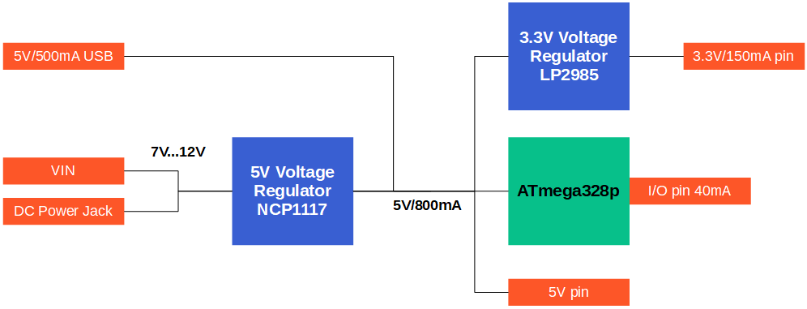

* Battery:
  + Deciding between 9V and 12V (9V is most recommended)
  + 9V lithium: <https://data.energizer.com/pdfs/l522.pdf>
  + Can last 8h if draw 100mA continuously
  + In standby mode: current draw only Arduino and IR draw significant current (60mA)
  + Estimated to last around 25-30 hours
* Using combination battery can boost up time